**PRESS RELEASE**

TROLLBEADS BRACELET: ETERNAL VITALITY BRACELET

*Embargoed until August 30, 2024*

**Eternal Vitality Bracelet – a limited edition from Trollbeads**

**The Temple Tree is a living testament of resilience and symbolises longevity and strength**

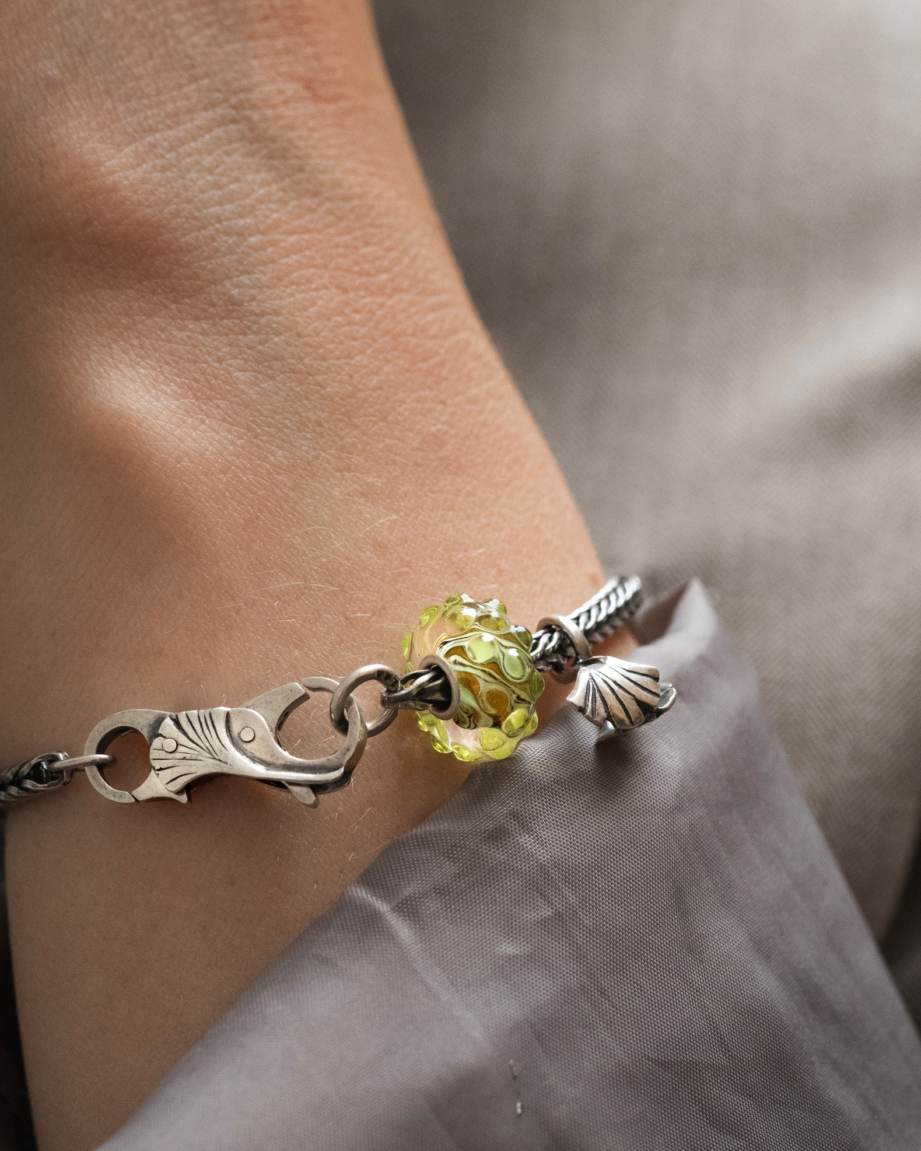

**The Temple Tree is a living testament of resilience and symbolises longevity and strength.**

The Eternal Vitality Bracelet is a beautiful new addition to the jewellery scene. This piece celebrates the profound symbolism of the Indian Temple Tree, renowned for its connections to growth, resilience, and spiritual connection.

Trollbeads is known for its unique and meaningful designs, and the limited edition Eternal Vitality Bracelet is no exception. It features a soft green glass bead with delicate buds, a sterling silver bead shaped like the sacred leaves of the Indian Temple Tree, and a stylish silver clasp resembling a ginkgo leaf. These elements together symbolise strength, vitality, and prosperity.

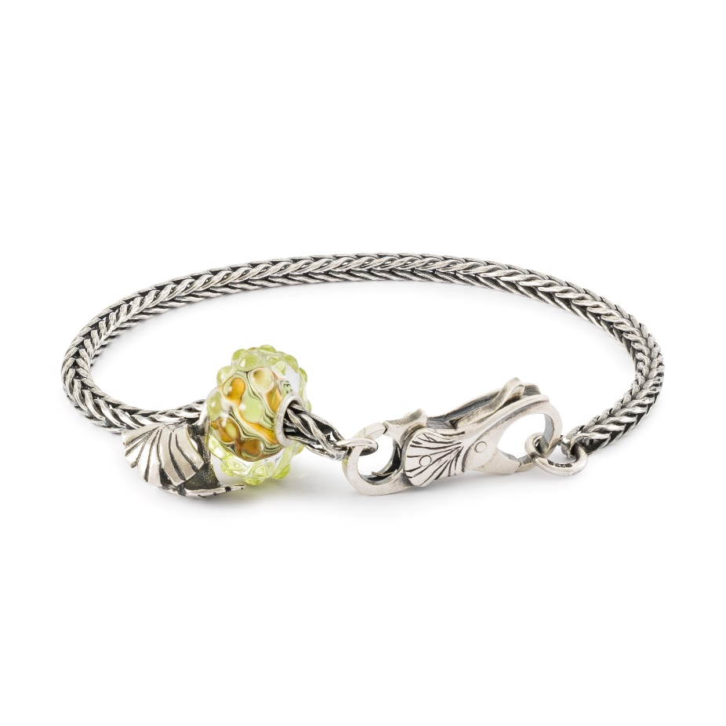

**Inspired by nature's beauty and spiritual significance**

The Indian Temple Tree, revered in Hindu culture and often found near temples, represents growth and a spiritual connection. By using this imagery, Trollbeads offers a bracelet that is not only beautiful but also rich in cultural and spiritual significance.

The Eternal Vitality Bracelet is ideal for those looking for a meaningful piece of jewellery that reflects nature’s beauty and the symbolism of the Temple Tree.

For those who like to express their individual style, Trollbeads offers the option to pair this bracelet with their new leather cord, giving you a fresh and unique look. The Eternal Vitality Bracelet fits perfectly into Trollbeads' collection of innovative and carefully crafted jewellery, cherished by enthusiasts worldwide.

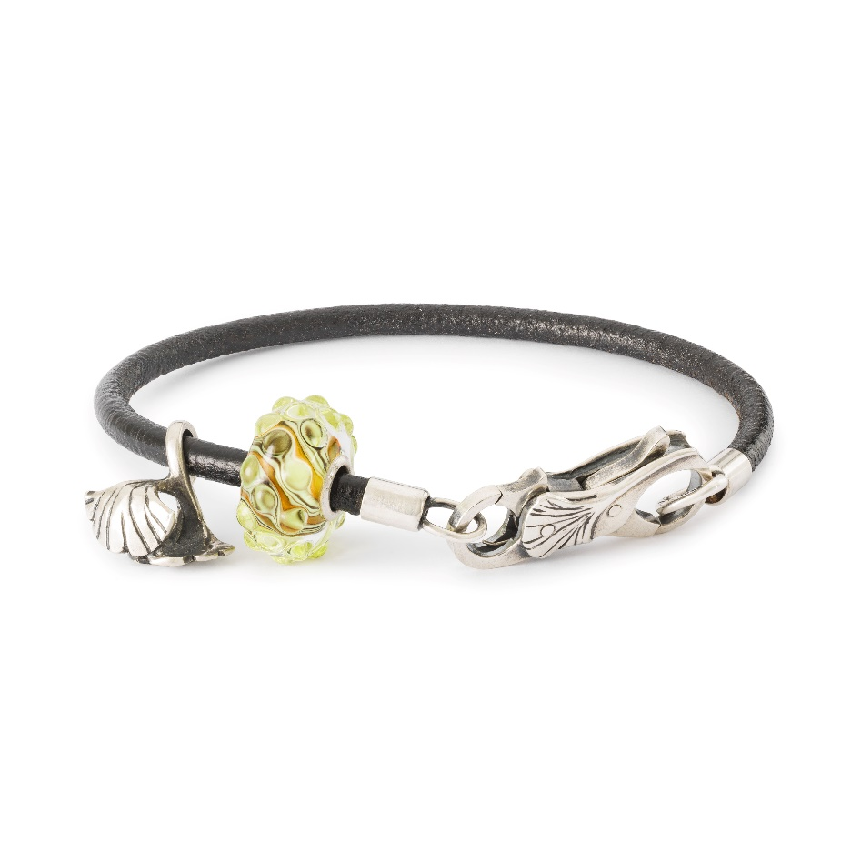

**Exquisite Craftsmanship**

Trollbeads, the original high-quality bead-on-bracelet concept, offers a wide range of beautiful beads, each a little piece of art telling a different story. All artisan glass beads are handmade in front of a red-hot, open flame, and Trollbeads is made from the highest quality raw materials, including 18 karat gold, sterling silver, artisan glass from Murano, freshwater pearls, and gemstones.

Start your story with the new Eternal Vitality Bracelet and continue your journey with your favourites from the Trollbeads collection. Whether as a gift to someone dear or as a personal expression of resilience and growth, this bracelet is sure to inspire and uplift.

The Eternal Vitality Bracelet is available in stores and online from 27th September.

**Prices:**

Eternal Vitality Bracelet EUR 119, -

*For more information, visit* [*www.trollbeads.com*](http://www.trollbeads.com)

**[Contact Information – Insert distributor information]**

***FACTS:***

*In 1976, Trollbeads emerged within the cozy confines of a small jeweller’s boutique in Copenhagen, Denmark, heralding the inception of the beads-on-bracelet phenomenon. Crafted with meticulous care, Trollbeads offers an exquisite array of interchangeable pieces, with its centrepiece being the beads themselves. Each element in the Trollbeads repertoire harbours its own captivating narrative, drawing inspiration from a rich tapestry of mythology, astrology, fairy tales, wildlife, spirituality, cultural heritage, and the cherished nuances of everyday life.*

*From bracelets to necklaces, earrings, rings, and accessories, Trollbeads presents a diverse spectrum of products, bestowing upon customers a truly unique experience. Here, they transcend the role of mere consumers to become designers, crafting personalized tales with each carefully selected piece. This original concept has captured the hearts of women worldwide, seamlessly blending superior craftsmanship with individual preferences.*

*Crafted from the finest materials such as 18-karat gold, Sterling silver, Italian glass, freshwater pearls, amber, and precious stones, Trollbeads epitomizes a fusion of traditional artistry and contemporary techniques. Notably, since 2001, the brand has excelled in crafting artisan glass beads, revered for their uniqueness and allure. Each artisan glass bead is individually handmade from red-hot glass in the open flame and no two Trollbeads are ever completely alike.*

*As a hallmark of Danish design legacy, Trollbeads embodies the principles of simplicity, functionality, and uncompromising quality. At its core, design reigns supreme, with a dedicated team of artisans and designers meticulously curating each collection. Over 60 designers have lent their creativity to Trollbeads, earning international acclaim and recognition, showcased at prestigious events like the Sculpture Objects & Functional Art exhibitions in Chicago and New York.*